**Databases**

**SQL Assignment**

1. Write an SQL query to show how many days you have been alive.

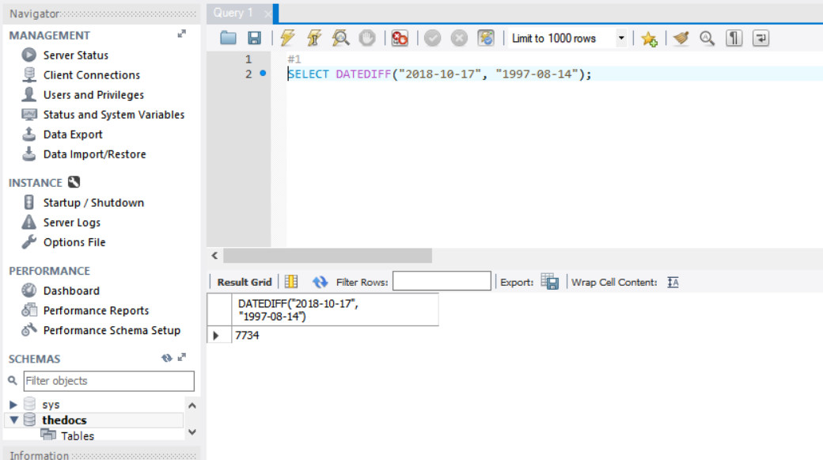

1. Update Doctor Lily Burke’s lastName to a lastName of your choice

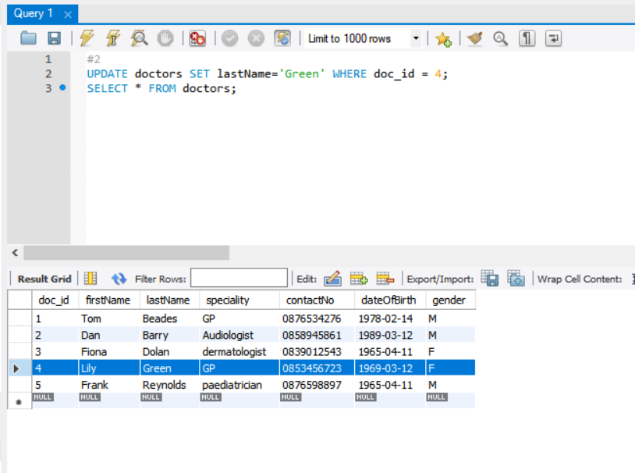

1. What is the name and price of the most expensive drug in the drugs table?

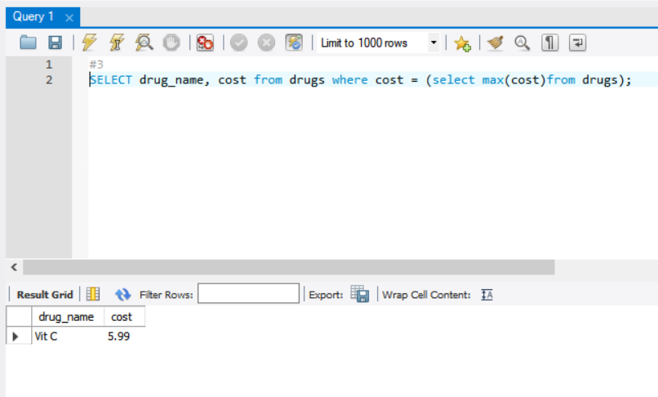

1. What is the name of the least expensive drug in the drugs table?

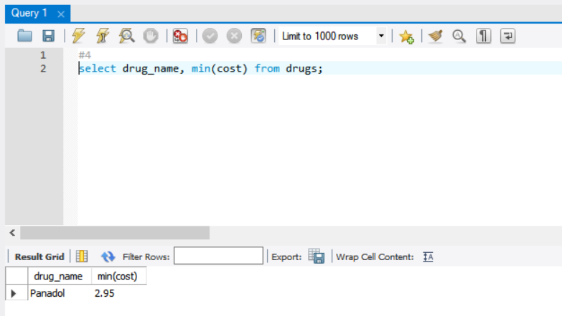

1. Select the patients who have no address2 details stored in thedoc patients table.

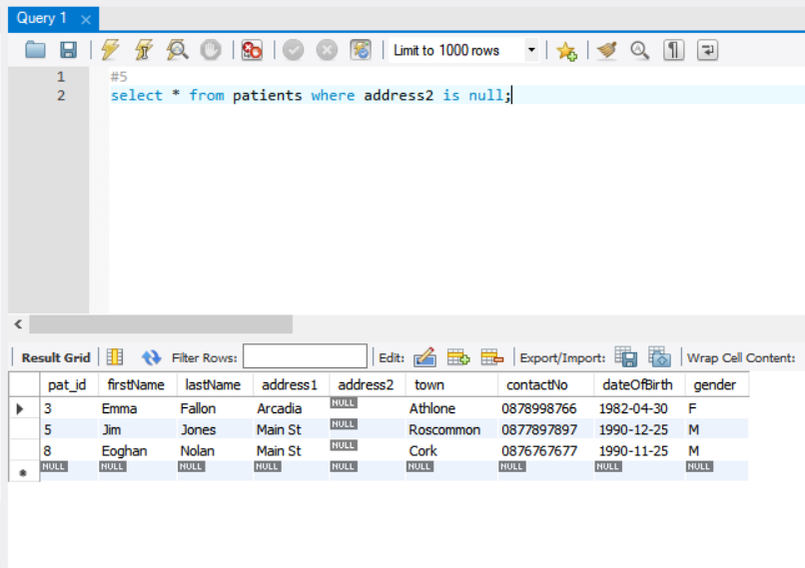

1. Choose 1 of these patients and update their details to store an address2 (Pick any town of your choice) in thedoc patients table.

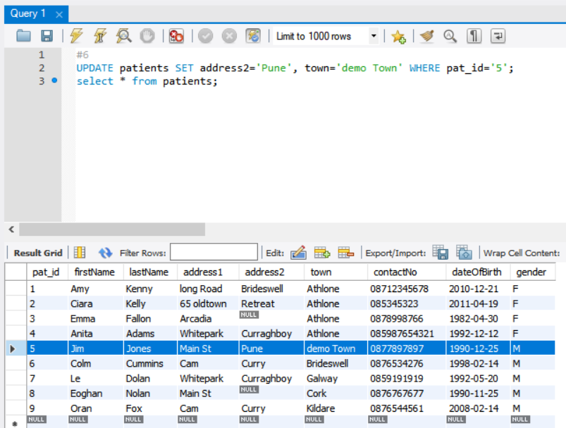

1. What is the average cost of a drug in the drugs table?

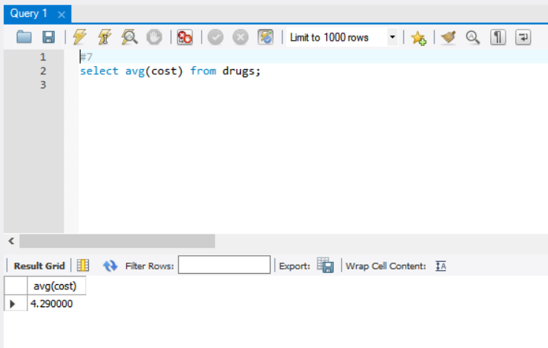

1. Count the different specialties of thedoc surgery

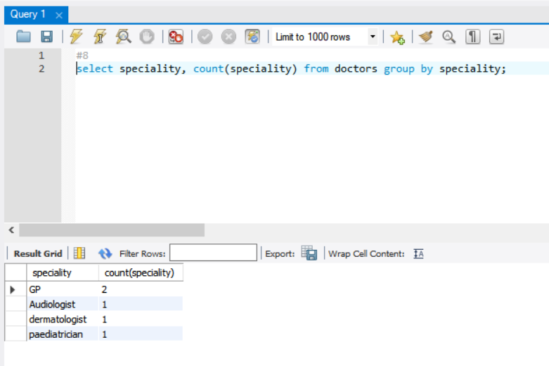

1. List the different specialities of thedoc surgery displaying the specialities in UPPERCASE letters.

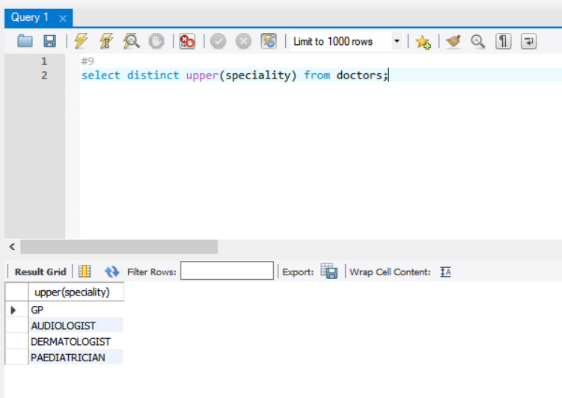

1. How many prescriptions did the paediatrician write?

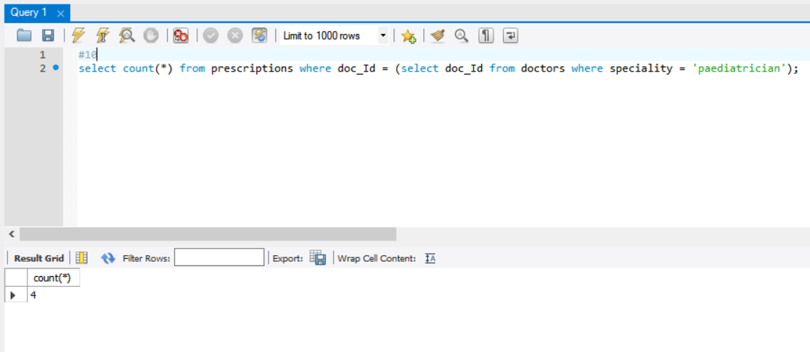

1. What are the names of the doctors who wrote the prescriptions for patient 6?

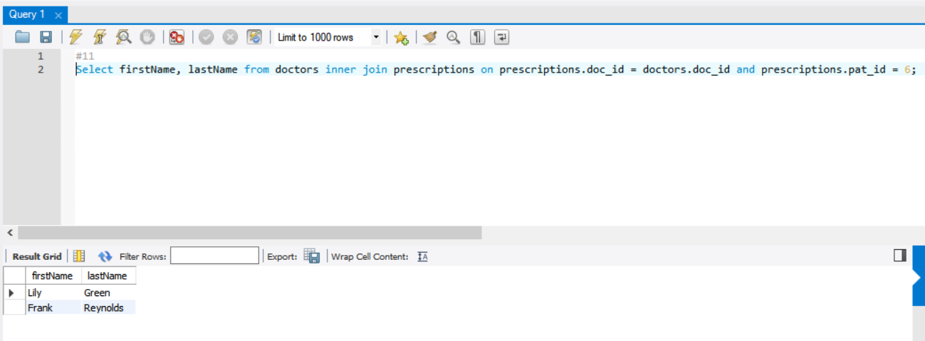

1. List the firstName, lastName of all the patients who had **no** prescription written for them.

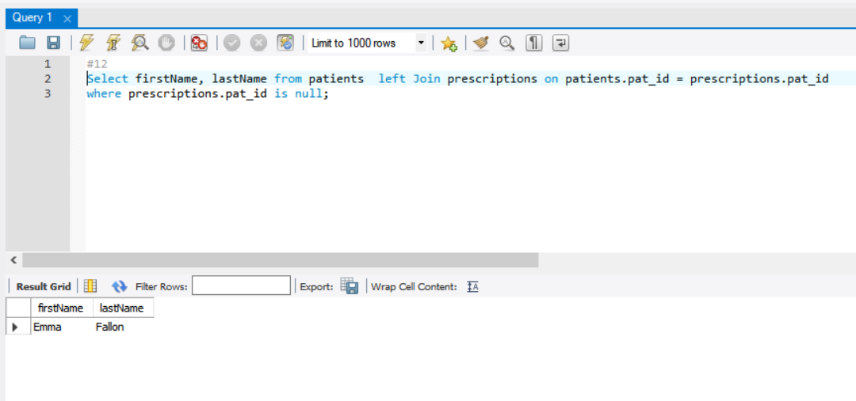

1. Insert any drug of your choice into the drugs table

List all the drugs in the drugs table – verifying your drug was added

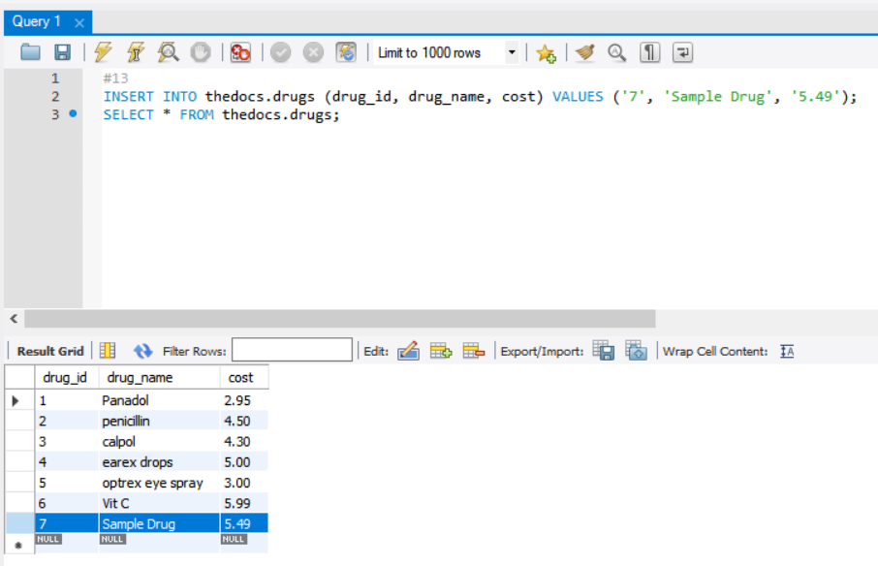

1. Now list all drugs that have been prescribed by the Doctors – your drug should not appear in the list

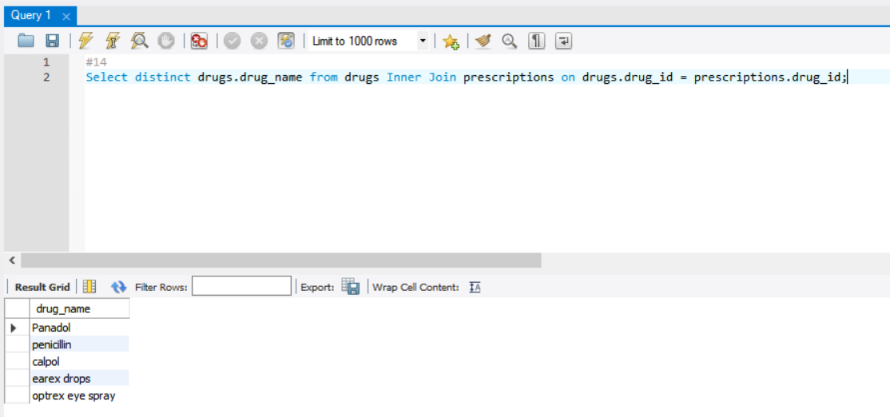

1. Add an attribute “Manufacturer” to the drugs tables.

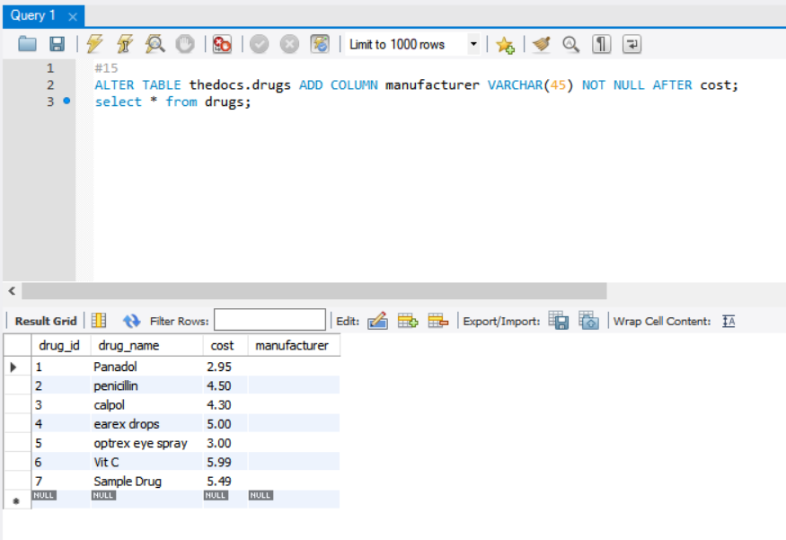

1. Update the drugs tables to record the manufacturer of Panadol and Calpol as GlaxoSmithKline.

